234.2

#include<iostream>

using namespace std;

class student

{

public:

void input(student &stu)

{

cout << "name?";

cin >> stu.name;

cout << "id?";

cin >> stu.id;

cout << "score?";

cin >> stu.score;

}

void output(student &stu)

{

cout << "name:" << stu.name << "\tid:" << stu.id << "\tscore:" << stu.score << endl;

}

private:

char name[20];

unsigned int id;

double score;

};

int main()

{

student s;

s.input(s);

s.output(s);

}

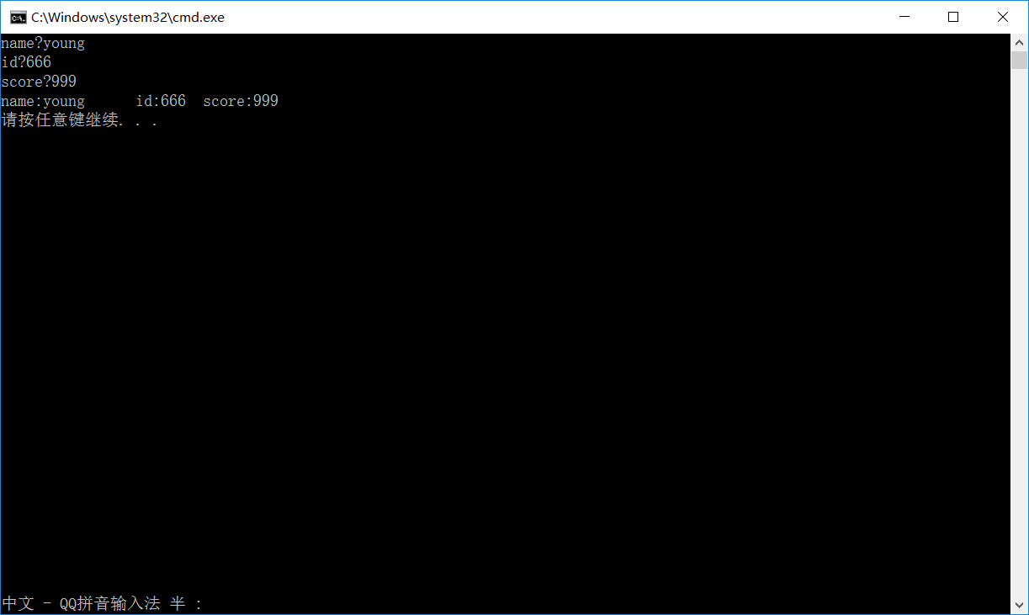

#include<iostream>

using namespace std;

class Book

{

public:

char bookname[128];

double price;

int number;

void display();

void borrow();

void restore();

};

void Book::display()

{

cout << "bookname:" << bookname << endl;

cout << "price:" << price << endl;

cout << "number:" << number << endl;

}

void Book::borrow()

{

number--;

cout << "number:" << number << endl;

}

void Book::restore()

{

number++;

cout << "number:" << number << endl;

}

int main()

{

int m;

Book a;

cin >> a.bookname >> a.price >> a.number;

a.display();

cout << "操作:";

cin >> m;

switch (m)

{

case 1:a.restore(); break;

case -1:a.borrow(); break;

default:cout << "error"; break;

}

return 0;

}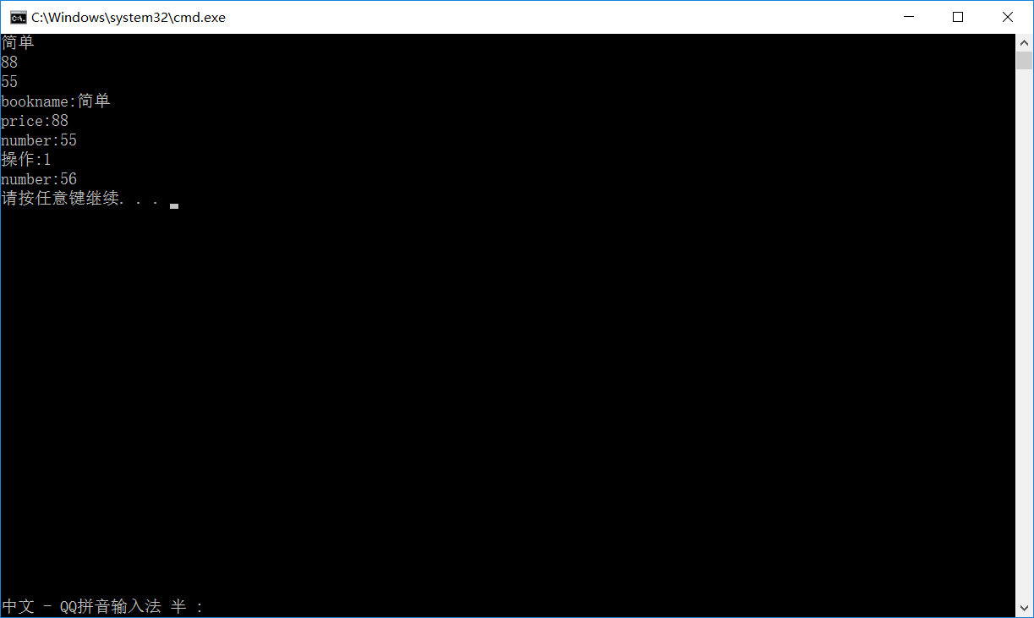

#include<iostream>

using namespace std;

class Student

{

public:

int score;

static int total;

static int count;

void scoretotalcount(double s)

{

cout << "please input socre"<<endl;

cin >> s;

score = s;

total = total + s;

++count;

}

static int sum()

{

return total;

}

static int average()

{

int y;

y= (total / count);

return y;

}

};

int Student::total = 0;

int Student::count = 0;

int main()

{

int i;

i = 0;

int b;

b = 0;

int c;

cout << "please input student number"<<endl;

cin >> c;

Student a[9999];

do

{

a[i-1].scoretotalcount(b);

a[i - 1].sum();

a[i - 1].average();

cout << "total:" << a[i - 1].total << "average:" << Student::average()<<endl;

i++;

} while (i <= c);

}

